Design and Implementation of a Web-Based Reporting Application
Parag S. Gawade¹, Ayush J. Kamble¹, Maheshvar B. Jadhav¹, Sushant T. Patil¹, Prof. Umesh A. Patil¹
¹Department of Computer Science and Engineering
D Y Patil Faculty of Engineering & Management, Talsande
Shivaji University, Kolhapur, Maharashtra, India

Abstract — A web-based reporting and analytics system is an essential tool for organizations that manage large volumes of operational and sales data. Traditional reporting processes often rely on manual data collection and spreadsheet-based analysis, which can be time-consuming, error-prone, and inefficient for large-scale operations. This paper presents the design and implementation of a web-based reporting and analytics application developed for a leading publication house operating across multiple states in India. The objective of the system is to provide management with accurate insights into sales performance through key performance indicators (KPIs), statistical analysis, and detailed reports. The system is implemented using modern web technologies including ReactJS for the user interface and ASP.NET Core Web API for backend services. Data is stored and managed using a MySQL relational database. The application provides interactive dashboards, graphical visualization of sales statistics, and export functionality for generating reports in Excel and PDF formats. The architecture follows a three-tier model consisting of presentation, application, and data layers to ensure modularity and maintainability. The implementation demonstrates how web-based reporting systems can simplify data analysis, improve accessibility to sales data, and support strategic decision-making in organizations with large operational footprints.
Keywords—Web Application, Reporting System, Data Analytics, Dashboard, Sales Analysis, Web API, Business Intelligence

INTRODUCTION
In the modern digital economy, organizations generate vast amounts of operational and transactional data on a daily basis. This data contains valuable information that can help organizations evaluate their performance, identify trends, and make informed strategic decisions. However, transforming raw data into meaningful insights requires efficient data analysis and reporting mechanisms.
Sales reporting is particularly important for organizations that operate across multiple regions or manage large product portfolios. Sales data provides insights into market demand, customer purchasing behavior, revenue generation, and product performance. When properly analyzed, this information can assist management in identifying profitable markets, forecasting future demand, and optimizing business strategies.
Traditionally, many organizations rely on manual reporting processes using spreadsheets or static documents. In such systems, data is collected from multiple sources and compiled manually to generate reports. While spreadsheet-based analysis can be useful for small datasets, it becomes inefficient when dealing with large volumes of transactional data. Manual reporting systems often suffer from several limitations, including slow report generation, increased risk of human error, lack of real-time updates, and difficulty in analyzing complex datasets.
The organization considered in this research is a leading publication house operating across multiple states in India. Due to its extensive distribution network and large sales volume, the company generates significant amounts of sales data from different geographical regions. Managing and analyzing this data using traditional reporting methods can be challenging and time-consuming.
To overcome these challenges, there is a need for an automated and centralized reporting system that can collect, process, and visualize sales data efficiently. Web-based reporting systems have emerged as an effective solution for such requirements. These systems allow organizations to store and analyze data using centralized databases while providing users with interactive dashboards and visual analytics tools.
The objective of this research is to design and implement a web-based reporting and analytics system that enables the organization to analyze its sales data effectively. The proposed system integrates modern web technologies such as ReactJS, ASP.NET Core Web API, and MySQL to provide an interactive reporting platform. Through dashboards, key performance indicators (KPIs), and statistical charts, the system enables stakeholders to monitor business performance and gain valuable insights from sales data.
By providing a centralized and automated reporting platform, the proposed system reduces dependence on manual data processing and improves accessibility to business information. This ultimately helps management personnel make better strategic decisions based on accurate and timely data analysis.

PROBLEM STATEMENT

Organizations with large-scale sales operations often face significant challenges in managing and analyzing their sales data effectively. When data is collected from multiple sources and stored in different formats, it becomes difficult to obtain a unified view of business performance. This lack of centralized reporting infrastructure can negatively impact decision-making processes within the organization.

The key problems addressed in this research include:

Lack of centralized reporting infrastructure

Difficulty in analyzing large volumes of sales data

Dependence on manual data processing

Limited visualization of business metrics

Inefficient decision-making due to delayed reporting

In many traditional environments, sales reports are generated manually using spreadsheet applications. Employees collect data from various departments and compile it into reports for analysis. While this approach may work for smaller organizations, it becomes inefficient and error-prone when dealing with large volumes of data generated across multiple locations.
Manual reporting systems also suffer from several operational limitations. One major limitation is the time required to generate reports. Preparing reports manually requires data extraction, formatting, and verification, which can significantly delay the availability of analytical insights. This delay can prevent management from responding quickly to changes in sales trends or market conditions.
Another challenge is the limited visualization capabilities provided by traditional reporting methods. Spreadsheet-based reports typically present data in tabular form, which makes it difficult for users to identify patterns, correlations, or anomalies in large datasets. Without graphical visualization tools, decision-makers may struggle to interpret complex data effectively.
Furthermore, organizations often require different types of analytical reports, such as performance metrics, sales comparisons, and statistical summaries. Generating these reports manually requires considerable effort and increases the risk of inconsistencies or data duplication.
The absence of an integrated reporting system also makes it difficult to share information among stakeholders. Different departments may maintain separate data records, leading to inconsistencies and lack of transparency in reporting.
These challenges highlight the need for a centralized web-based reporting platform that can automate data analysis, provide interactive visualizations, and generate accurate reports in real time. The development of such a system can significantly improve the efficiency and reliability of sales reporting processes.

OBJECTIVE OF THE SYSTEM

The primary objective of the proposed system is to design and implement a web-based reporting and analytics platform that enables efficient collection, processing, and visualization of sales data. The system aims to simplify the process of analyzing large volumes of transactional information and provide meaningful insights that can support organizational decision-making. In organizations with large operational networks, sales data is generated from multiple regions and departments. Without a centralized reporting infrastructure, analyzing such distributed data becomes difficult and time-consuming. Therefore, the development of an integrated web-based reporting system helps in consolidating information and presenting it in a structured and easily interpretable format.

The specific objectives of the proposed system are as follows:

To develop a centralized platform for sales data analysis

One of the major objectives of the system is to provide a centralized platform where sales data from various sources can be stored, managed, and analyzed efficiently. By maintaining all reporting data within a single database system, the platform eliminates data redundancy and ensures consistency in reporting. A centralized system also simplifies data retrieval and allows management to obtain a unified view of organizational performance.

To provide graphical dashboards for visual representation of data

Data visualization plays a crucial role in understanding complex datasets. The system aims to provide interactive dashboards that present sales information using graphical elements such as charts and graphs. These visualizations enable users to quickly identify trends, patterns, and performance indicators. Graphical dashboards make it easier for stakeholders to interpret analytical results and monitor business performance without manually analyzing large tables of data.

To generate detailed reports for statistical analysis

Another objective of the system is to generate comprehensive reports that provide detailed insights into sales transactions and performance metrics. These reports include information such as the number of transactions, total sales value, and average transaction amounts. Detailed reports allow users to conduct deeper statistical analysis and evaluate different aspects of the organization's sales operations.

To enable export of analytical reports in multiple formats

Organizations often need to store or share analytical reports for documentation, presentations, or further analysis. Therefore, the system provides functionality to export generated reports in commonly used formats such as Excel and PDF. This feature ensures that users can easily distribute reports among stakeholders and maintain proper records of business analytics.

To implement a secure user authentication mechanism

Security is an important requirement in any data-driven system. The reporting platform includes a user authentication mechanism that ensures only authorized users can access the system. New users must be approved by the system administrator or owner before they can use the platform. This authentication process protects sensitive sales information and prevents unauthorized access.

To improve accessibility and usability of reporting tools

The system is designed with a user-friendly web interface that allows users to access reporting features easily through a web browser. By using modern web technologies, the platform ensures smooth navigation, intuitive dashboard layouts, and responsive design. Improving usability helps users perform data analysis more efficiently without requiring advanced technical knowledge.

To reduce dependency on manual reporting processes

Traditional reporting systems often involve manual data compilation and spreadsheet-based analysis, which can be time-consuming and prone to errors. One of the objectives of the proposed system is to automate the reporting process by integrating database management, data processing, and visualization tools. Automation significantly reduces the effort required to generate analytical reports.

To support better strategic decision-making

The ultimate objective of the reporting system is to support management in making informed business decisions. By providing accurate data, visual analytics, and detailed reports, the platform enables stakeholders to monitor sales performance, evaluate business strategies, and identify opportunities for improvement.

LITERATURE REVIEW
The increasing importance of data-driven decision-making has led to significant advancements in reporting and analytics systems. Modern organizations rely heavily on business intelligence tools to transform raw data into actionable insights.
These systems integrate databases, analytics engines, and visualization frameworks to provide comprehensive reporting capabilities. Traditional reporting systems were primarily based on spreadsheet applications and manual data processing techniques. While these systems allowed basic data analysis, they lacked scalability and automation features required for large datasets. As organizations expanded their operations, the need for more advanced reporting platforms became evident.
Web-based reporting systems have emerged as a popular solution for managing and analyzing large volumes of organizational data. These systems utilize centralized databases and web technologies to provide users with interactive dashboards and real-time analytical insights. By integrating web interfaces with backend data processing services, modern reporting platforms allow users to access reports from any location using a web browser. Data visualization plays a crucial role in modern reporting systems.
Visualization techniques such as bar charts, line graphs, and pie charts help users interpret complex datasets more effectively. Research studies have shown that visual analytics improves the speed and accuracy of decision-making by presenting data in an intuitive and easily understandable format.
Enterprise-level reporting platforms often include features such as key performance indicators, statistical analysis tools, and automated report generation. These features enable organizations to monitor their performance continuously and identify trends in their operational data.
Despite the availability of commercial business intelligence tools, many organizations prefer customized reporting systems tailored to their specific requirements. Custom-built solutions allow organizations to integrate their existing databases and workflows while providing flexibility in report generation and data visualization.
The proposed system in this research follows a similar approach by developing a dedicated web-based reporting platform for analyzing sales data within a publication house. By combining modern web development technologies with database management systems, the system provides a scalable and efficient environment for sales reporting and analytics.

SYSTEM ARCHITECTURE

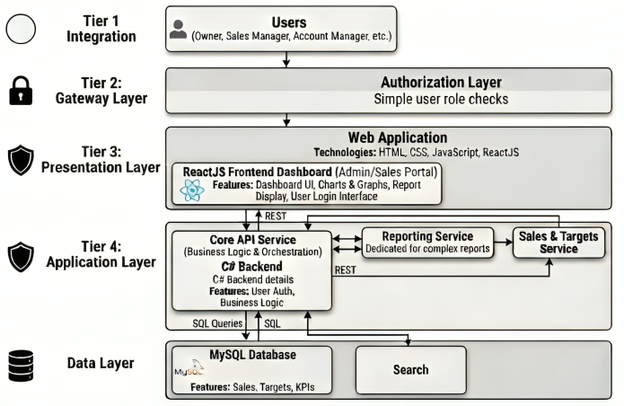

Figure 1: Three-tier architecture of the proposed reporting system

VI. SYSTEM KEY FEATURE
The proposed reporting system provides several features designed to simplify sales data analysis and reporting. These features allow users to monitor business performance through dashboards, graphical visualizations, and detailed reports.

- Key Performance Indicators (KPI)
Key performance indicators are essential metrics that summarize business performance in a concise format. The system calculates and displays KPIs that provide quick insights into sales performance.

The KPIs implemented in the system include monthly sales growth, average profit margin, and monthly sales bookings. These indicators help management evaluate whether sales targets are being achieved and identify areas requiring improvement. By presenting KPI values on the dashboard, the system enables decision-makers to monitor organizational performance efficiently.

- Statistical Visualization
Statistical visualization is an important component of modern reporting systems because it allows users to understand complex datasets through graphical representations. The proposed system provides several chart-based visualizations to display sales data.

- Detailed Reporting Module
In addition to summarized metrics and visual charts, the system provides a detailed reporting module that allows users to analyze raw sales data. This module generates structured reports containing information such as the total number of sales transactions, average transaction value, and total sales revenue.

These reports are useful for performing deeper analysis and identifying specific trends or patterns in sales data. The system also supports exporting reports in Excel and PDF formats, allowing users to store or share analytical reports with other stakeholders.

VII. SYSTEM WORKFLOW
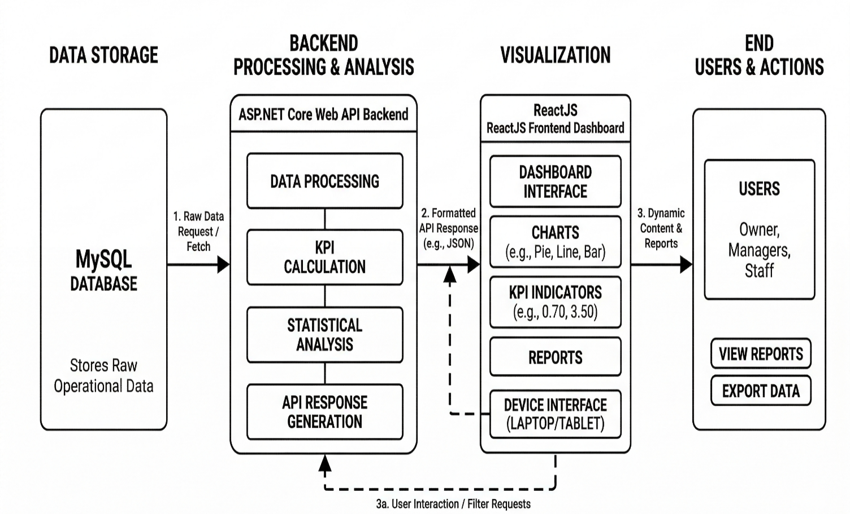

Figure 2: Workflow of the reporting and analytics system

VIII. SYSTEM DESIGN
The system design focuses on developing a modular, scalable, and maintainable architecture that supports efficient processing of sales data and generation of analytical reports. A modular design approach ensures that different components of the system can operate independently while still interacting with each other through defined interfaces. This approach simplifies system maintenance, improves scalability, and allows future enhancements without affecting the entire system.

The reporting platform is designed using a three-tier architecture, consisting of the presentation layer, application layer, and data layer. Each layer performs a specific function within the system:
- Presentation Layer – Responsible for user interaction through the web interface.
- Application Layer – Handles business logic, data processing, and API communication.
- Data Layer – Stores and manages all system data using a relational database.
To implement the required functionality, the system is divided into several functional modules. Each module performs a specific task within the reporting platform.

- User Authentication Module
The User Authentication Module is responsible for controlling access to the system and ensuring that only authorized users can use the reporting platform.

The main responsibilities of this module include:
- Managing user registration and login processes
- Verifying user credentials during authentication
- Allowing only approved users to access the system
- Preventing unauthorized access to sensitive sales data
- Maintaining basic user account information

In this system, user accounts must be approved by the administrator or owner before they can access the platform. This ensures that only legitimate organizational users are able to view or analyze business data. The authentication mechanism improves the overall security and reliability of the reporting system.

- Data Processing Module
The Data Processing Module plays an important role in retrieving and analyzing sales data stored in the database. This module communicates with the backend APIs developed using ASP.NET Core Web API to fetch relevant information from the database.

The major functions performed by this module include:

- Retrieving sales data from the MySQL database
- Performing data filtering and aggregation operations
- Calculating business metrics such as KPIs
- Preparing datasets required for charts and reports
- Sending processed data to the visualization layer

This module processes raw sales data and converts it into meaningful analytical information. For example, calculations such as monthly sales growth, average profit margin, and total sales bookings are performed in this stage.

Efficient data processing ensures that the system can generate accurate insights even when handling large volumes of sales transactions.

- Visualization Module
The Visualization Module is responsible for presenting processed data in graphical form. Visual representation of data helps users understand complex datasets more easily compared to traditional text-based reports.

This module generates various types of charts and dashboards to display sales statistics. The visualization module performs the following functions:
- Converting processed data into interactive charts and graphs
- Displaying sales performance trends through dashboards
- Presenting statistical comparisons such as sales targets vs actual performance
- Providing an easy-to-understand interface for business analysis
- Allowing users to quickly identify patterns and trends in sales data

Graphical visualizations such as bar charts, line graphs, and comparison charts help users interpret sales performance more effectively. These dashboards allow decision-makers to monitor business performance in real time and make informed strategic decisions.
- Reporting Module
The Reporting Module is responsible for generating detailed analytical reports based on the available sales data. These reports provide structured datasets that can be used for further statistical analysis and documentation.

The reporting module provides several key functionalities:

- Generating detailed sales transaction reports
- Calculating average transaction values and total sales revenue
- Displaying sales performance summaries
- Allowing users to download reports for documentation
- Supporting export functionality in Excel and PDF formats

Reports generated by the system help users analyze historical sales data and evaluate organizational performance. Export functionality also allows reports to be shared with other stakeholders or used in presentations, meetings, and strategic planning activities.

- Benefits of the Modular System Design
The modular design approach adopted in the system provides several advantages:
- Improves system maintainability by separating functionality into modules
- Allows independent development and testing of components
- Simplifies future system enhancements
- Improves system scalability for handling larger datasets
- Reduces the complexity of system management

IX. TECHNOLOGY USED
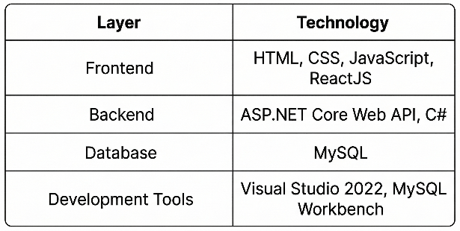
Figure 3: Technology Stack

X. ADVANTAGES OF THE SYSTEM
The proposed web-based reporting and analytics system provides several advantages over traditional reporting approaches that rely on manual data compilation and spreadsheet-based analysis. By integrating database management, web technologies, and visualization tools, the system improves the efficiency and effectiveness of sales data analysis.

- Centralized access to sales data

One of the major advantages of the proposed system is the centralized storage and management of sales data. In traditional environments, sales information is often distributed across multiple spreadsheets or separate data sources, making it difficult to obtain a consolidated view of business performance. The proposed system integrates all sales data into a single database, allowing users to access and analyze information from a centralized platform. This improves data consistency and simplifies the process of retrieving relevant information.

- Reduced dependency on manual reporting
Manual reporting processes require employees to collect, organize, and analyze data from multiple sources before generating reports. This process is time-consuming and increases the risk of human error. The proposed system automates many aspects of the reporting process by retrieving data directly from the database and generating reports automatically. Automation significantly reduces the effort required to produce analytical reports and ensures higher accuracy in the reporting process.

- Improved data visualization through dashboards
The system provides interactive dashboards that present sales information using graphical charts and statistical visualizations. Visual representation of data allows users to understand complex datasets more easily compared to traditional tabular reports. Charts such as bar graphs, line charts, and comparison graphs help stakeholders quickly identify sales trends, performance patterns, and potential issues in business operations.

- Easy export of reports for documentation
Another advantage of the system is the ability to export generated reports in widely used formats such as Excel and PDF. Export functionality allows users to store reports for future reference or share them with other stakeholders within the organization. This feature is particularly useful for preparing presentations, conducting meetings, or maintaining official documentation of business performance.

- Better accessibility for multiple stakeholders
The web-based architecture of the system allows users to access the reporting platform through a standard web browser. This improves accessibility and allows multiple stakeholders to analyze data simultaneously. Users such as the owner, sales operations manager, account manager, and sales development representatives can all access relevant sales reports from the system, enabling better collaboration and decision-making.

- Improved decision-making support
By providing accurate, timely, and visually represented sales data, the system helps management personnel make more informed decisions. The availability of real-time insights into sales performance allows organizations to respond quickly to market trends and adjust business strategies accordingly.
XI. LIMITATIONS
Although the proposed system provides several advantages, it also has certain limitations that should be considered when evaluating its performance and scalability.

- Local server deployment
Currently, the reporting system is deployed on a local server environment. While this configuration is suitable for development and testing purposes, it restricts system accessibility to users within the local network. Remote users may not be able to access the platform without additional network configurations. Deploying the system on a cloud infrastructure could significantly improve accessibility and scalability.

- Limited performance optimization
The current implementation focuses primarily on system functionality rather than advanced performance optimization techniques. As the volume of sales data grows over time, the system may require database optimization methods such as indexing, query optimization, and caching mechanisms to maintain efficient performance. Without these improvements, large datasets could potentially affect system responsiveness.

- Basic authentication mechanism
The system currently implements a simple user authentication mechanism to control access. However, more advanced security features such as role-based access control and permission management are not yet implemented. Adding these features would allow organizations to define different access levels for various user roles and enhance system security.

- Limited integration with external systems
The system is currently designed as a standalone reporting platform. Integration with other enterprise systems such as accounting software or enterprise resource planning systems has not yet been implemented. Such integrations could enhance the functionality of the system by enabling automatic data synchronization between different business applications. Despite these limitations, the system provides a strong foundation for future improvements and can be further enhanced to support larger and more complex organizational environments.
XII. FUTURE WORK
Several enhancements can be implemented in the future to improve the functionality, scalability, and usability of the reporting system. These improvements can transform the platform into a more advanced business intelligence solution capable of supporting large-scale organizational operations.

- Cloud-based deployment
One potential improvement is deploying the system on a cloud-based infrastructure. Cloud platforms provide scalable computing resources, improved availability, and remote accessibility. By hosting the reporting platform on a cloud server, users from different geographical locations could access the system without relying on a local network environment.

- Real-time data processing
The current system processes sales data in a standard request-response manner. Future versions of the system could incorporate real-time data streaming technologies to update dashboards instantly as new transactions occur. Real-time analytics would allow organizations to monitor sales performance continuously and respond quickly to changes in market conditions.

- Advanced analytics and predictive modeling
Another important area for future development is the integration of advanced data analytics techniques. Machine learning algorithms and predictive models could be incorporated to analyze historical sales data and forecast future sales trends. Predictive analytics could help organizations anticipate demand patterns and make proactive business decisions.

- Role-based access control
Implementing role-based access control mechanisms would enhance system security and usability. Different user roles such as administrators, managers, and analysts could be assigned specific permissions to access particular features of the system. This would ensure that sensitive information is accessible only to authorized personnel.

- Integration with external enterprise systems
Future versions of the system could also integrate with other enterprise applications such as inventory management systems, customer relationship management systems, and accounting platforms. Such integrations would enable seamless data exchange between different business applications and improve overall operational efficiency. By incorporating these improvements, the proposed reporting system can evolve into a comprehensive business intelligence platform capable of supporting complex organizational analytics.

XIII. CONCLUSION
This research presented the design and implementation of a web-based reporting and analytics system developed to support sales data analysis for a publication house operating across multiple states in India. The system addresses the challenges associated with traditional reporting methods by providing an automated platform for collecting, processing, and visualizing sales data. The proposed platform integrates modern web technologies including ReactJS for the user interface, ASP.NET Core Web API for backend services, and MySQL for database management. The system architecture follows a three-tier model consisting of the presentation layer, application layer, and data layer, which ensures modularity, maintainability, and scalability. Through interactive dashboards, graphical charts, and detailed reports, the system enables users to analyze sales performance effectively. Key performance indicators provide summarized insights into business metrics, while statistical visualizations allow users to identify trends and patterns in sales data. The ability to export reports in Excel and PDF formats further enhances the practicality of the system for documentation and business analysis.
The implementation demonstrates that web-based reporting platforms can significantly improve the efficiency of data analysis and reporting processes. By automating data processing and providing intuitive visualization tools, the system reduces dependency on manual reporting methods and improves accessibility to analytical insights.
Although the current implementation is deployed on a local server environment and includes limited optimization features, the system provides a strong foundation for further development. Future enhancements such as cloud deployment, real-time analytics, and predictive modeling could significantly extend the capabilities of the platform. Overall, the proposed reporting system demonstrates how modern web technologies can be utilized to develop efficient and scalable analytics platforms for organizations that rely heavily on sales data for strategic decision-making.

XIV. REFERENCES
[1] Stuart Russell and Peter Norvig, Artificial Intelligence: A Modern Approach, 3rd ed., Pearson, 2010.

[2] Martin Fowler, Patterns of Enterprise Application Architecture, Addison-Wesley, 2003.

[3] Ralph Kimball and Margy Ross, The Data Warehouse Toolkit, Wiley, 2013.

[4] Oracle Corporation, MySQL 8.0 Reference Manual, Oracle Documentation.
.

[5] Microsoft, ASP.NET Core Web API Documentation, Microsoft Docs.

[6] Meta, ReactJS Documentation, React Developer Guide.

[7] Thomas H. Davenport, “Competing on Analytics,” Harvard Business Review, vol. 84, no. 1, pp. 98-107.

[8] Edward Tufte, The Visual Display of Quantitative Information, Graphics Press, 2001.

